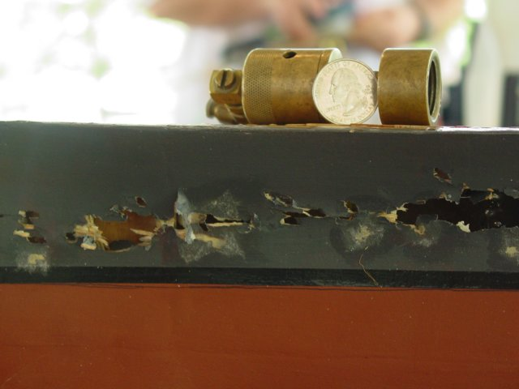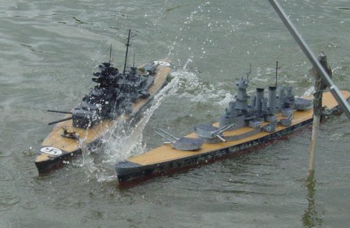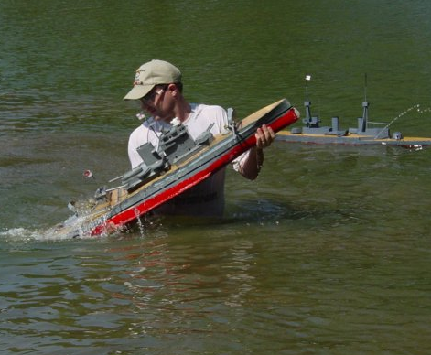

What is Model Warship Combat?
Model Warship Combat (MWC), Inc. is a group of fun loving people who build and battle 144th scale warships from World War I and World War II. The ships are 2’-7’ long, 5”-12” wide and weigh 5lbs-60lbs. They are sheeted with 1/32nd balsa wood and are armed with low powered bb guns. The ships are battery powered and remote controlled. The bbs shoot through the thin balsa wood and make small (Sometimes large) holes in the hull. Each ship has a pump on board, but when the damage is too great the ship sinks. The ships are designed and built to take the punishment, and are very easy to repair. Usually a repair is no more than covering a bb hole with a silkspan patch (very much like tissue paper but stronger) and a light covering of glue or quick-drying paint. When dry, the hole is patched. The sensitive electronics, including the bulk of the radio equipment, are usually protected from the water, either through the use of watertight boxes, or by some other form of waterproofing. The electrical drive motors aren't usually protected, as it's not too hard to find inexpensive motors that aren't bothered by exposure to water.
Having remote controlled bbs flying around seems to be asking for trouble, be we try our best to think of safety first. As mentioned above, the bb cannons are relatively low-powered, firing the bbs hard enough to give a good sting but not hard enough in most cases to break the skin. Thus our main concern is for eye-safety, and we have other safety rules in place to try and keep the bbs down below eye-level of most adults. For instance, the destroyers and cruisers tend to roll quite a bit when they turn, and so bb cannons are only allowed to fire directly off the bow and/or stern on these ships, to cut down on the shots going high. Even with all of our precautions, bbs will bounce, and as such, eye protection for all combatants and spectators is mandatory.
Fiberglass hulls are available for sale by individuals and companies. One supplier that is very helpful to rookies who want to purchase a fiberglass hull kit is Battler's Connection. They have a great selection of hulls, and complete warship kits and accessories. Battler's Connection is owned by Rick King, Tim Krakowski & Charley Stephens all are veteran battlers and very helpful to rookies building their first warship. The kits are very complete, including everything you need to construct a working model warship.
The local club in MN is Port Polar Bear. We meet 1-2 times a month for a battle or building in the winter. Battles are typically held in Ham Lake in one of the club member’s back yard. We also have battles in Roseville and Chanhassen when his pond is not available.
Battles are two sorties. Before each sortie all ships load their bbs, CO2 tanks and batteries. When battle is called each team tries to sink the other team’s ships, or at least give them more holes then you get in return. After you run out of bbs or are in danger of sinking you call “Five minuets”. You then start your timer and have to stay on the water without shooting anyone for five minuets. After all ships are off of their five everyone reloads bbs and CO2, small ships can change batteries. Then we repeat the process for sortie two. After both sorties holes and sinks are counted to find the winning fleet. The battles are fast and action packed, a “Knife fight in a phone booth”. Ships typically have their guns aimed to hit the water only a few inches away from their own hull. So you have to pull right up next to someone to make holes in them.
Membership in MWC, Inc. is open to any person interested in the hobby of R/C model warship combat. There are no age limits to join, however minors must have a parent or guardian sign their membership form. The hobby of model warship combat is an excellent opportunity for parents to become involved with their children in a life-long hobby that encourages creativity through experimentation and construction of model ships combined with good sportsmanship and teamwork by participation in combat events.
MWC offers assistance to beginners in selecting and building combat ships through electronic forums and contacts with veteran captains. Local chapters of the MWC sponsor several combat events and meetings throughout the year (but usually during the winter for non-combat building sessions) that the beginner can use to aid their entry into the hobby. Our main event (basically our Super Bowl) for the year is the National Championships (Nats) held in July of each year at varying places around the country.
Since MWC is a corporation, this has allowed it to secure a liability insurance policy to cover both the organization and its members during R/C warship combat activity. This insurance is included in the price of dues so all MWC members are automatically covered. The MWC organization can also assist local members in securing locations to enjoy the hobby of R/C model warship combat. Our safety and ship construction rules are geared towards minimizing the inherent dangers to both participants and bystanders that are posed by our ships. Safety is the number one driving force behind MWC. Having fun and good fellowship with friends is the second.
Nationals is Coming to Ramsey, MN on July 14-18
The Port Polar Bear Fleet will be hosting NATS July 14-18 Fleet battles start at 10am & go until 3pm.
Local battles are scheduled every month the water is ice free. In the winter we have monthly building meetings.
Local Contacts portpolarbear.com
Bob Hoernemann r_hoernemann@hotmail.com
Home: 952-448-8808 (7PM-8PM Weekdays, Weekends 10AM-8PM)
Ben Radenbugh benny2.0@comcast.net
Larry Dahl larry.dahl@lmco.com
Home: 651-450-0275 (8PM-11PM, Weekends 10AM-11PM)
John "Curly" Barrett curlybarrett@msn.com
Home: 651-639-8329 (6PM-9PM)
We have other local battlers all over the metro area also in Mora, St. Cloud, Rochester, Winona, Duluth and Wisconsin.
Check us out at
mwci.org & portpolarbear.com
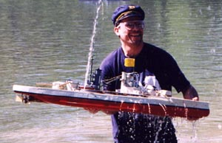
John "Curly" Barrett retrieves his ship after sinking.
He'll have it back on the water in an hour which is why he's smiling.
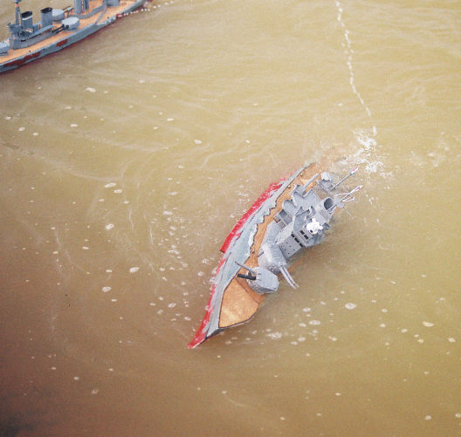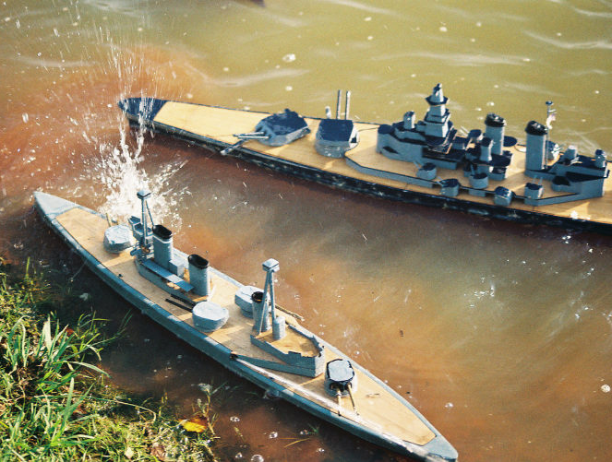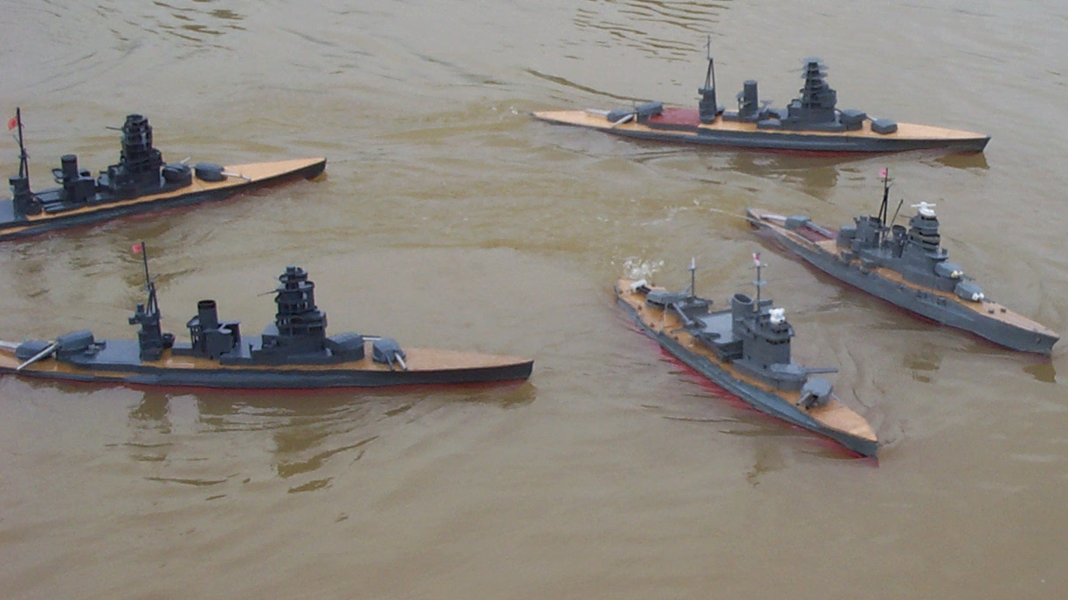
Good Web Sites
mwci.org The home page for the national club all the following sites are on the links page.
Battlers Connection battlersconnection.com
"Has an excellent collection of kits and accessories using the latest manufacturing techniques. For keeping you on the
competitive edge in R/C model warship combat. The beginner's best choice." - Charley Stephens
Texas Naval Brigade - Gulf Coast Squadron (TNB-GCS) mwci.org/chapters/TNB-GCS
GOOD PICTURES ON THIS SITE
"The TEXAS NAVAL BRIGADE - GULF COAST SQUADRON is a group of new 1/144 scale model warship battlers in the Houston, Texas area. The club is building both Axis and Allied warships, and is an active chapter of Model Warship Combat, inc. The website chronicles their experiences while building cruisers." - Steve Reichenbach
The Commodore's Page mwci.org/chapters/cpearce
GOOD PICTURES AND ARTICLES ON THIS SITE
Geared towards the Allied end of the battling spectrum, this site contains many excellent photos.
Ron Thibault's Page mwci.org/chapters/rthibault
VERY GOOD ARTICLES ON THIS SITE
"A combat site with several 'How To' articles covering a broad range of ship construction, as well as pictures and links to many other sites. In addition information that will be of interest to those who use a lathe in the fabricating of ship components." - Ron Thibault
Port Polar Bear (PPB) mwci.org/chapters/PPB
THE LOCAL MN CLUB
The guys up in the great white north. Rumors abound that they fit skates to their ships for winter use.
Florida Region Attack Group (FRAG) mwci.org/chapters/FRAG
LOTS!! OF GREAT PICTURES ON THIS SITE
"Representing the Florida gang of bb-happy modelers (one of the fastest growing in the hobby) with links,
pictures, and articles, and contact info. We battle in Orlando, north Florida (Ocala area) and south Georgia (Baxley & Atlanta) approximately once a month." - Jeff Lipp

