Port Polar Bear
MODEL WARSHIP COMBAT ????
R/C MODEL WARSHIP COMBAT is a hobby where would be naval captains build 144th scale models of World War I and II era naval warships for one specific purpose, TO DO BATTLE with other similarly built and equipped models. Models are specifically constructed to participate in safe, fun, and exciting combat. People all over the U.S. have become involved with this sport/hobby and have gotten completely hooked. The thrill of putting your ship and skill as a captain on the line in "Real" combat is something no other radio controlled model hobby can match. The object of radio controlled warship combat is quite simply "SINK THE ENEMY". These model ships are built to 1/144 scale, or one inch equals twelve feet (1" = 12'). They have a rigid framework of aircraft plywood or fiberglass with all exterior vertical surfaces sheeted with very thin balsa wood. This allows for easy penetration by low velocity BB's. Each ship is armed with from 1 to 7 BB cannons (Depending on the class of ship modeled) powered by compressed CO2 gas that the captain controls from shore by radio control. The Captain also controls the ships steering, throttle via radio control. The ships are powered by small electric motors and rechargable batteries. Ships are also allowed to carry one or more small bilge pumps to evacuate water that comes into the hull. In order to prevent damage to the radio receiver and servos, they are built into a watertight box inside the hull. Patching a model involves nothing more than small pieces of Silkspan model covering tisue, model dope (paint), and a small brush. If what you have read here about the "Magnificent Obsession" intrigues you, you are not alone, many people in the U.S. and other places are getting the itch to build a real battling warship. If you think this hobby/sport is for you, then now is the time for you to
GET YOUR SHIP TOGETHER TODAY!!
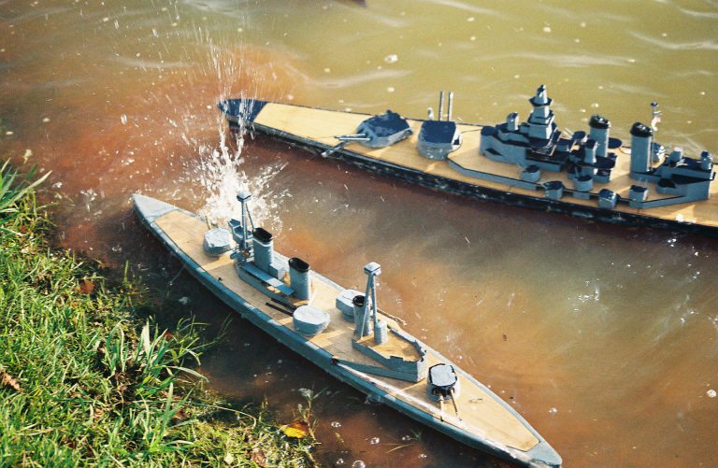
Targets Wanted!!!
For more info at www.portpolarbear.com/

