What is the MWC?

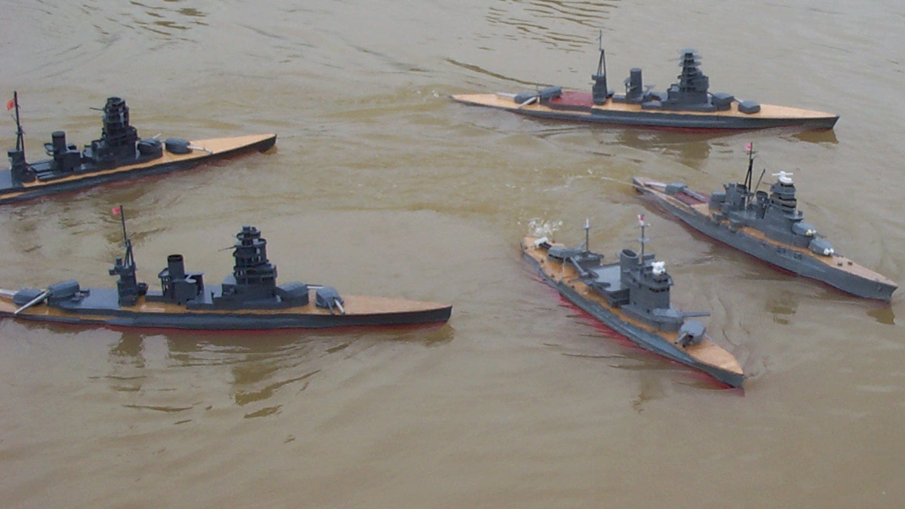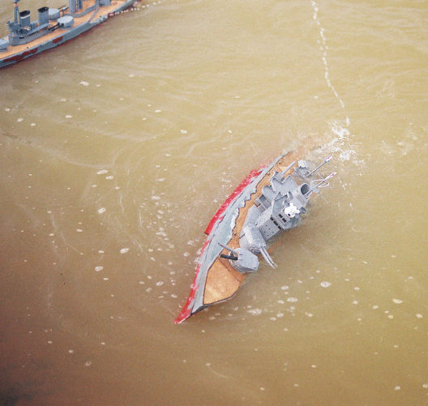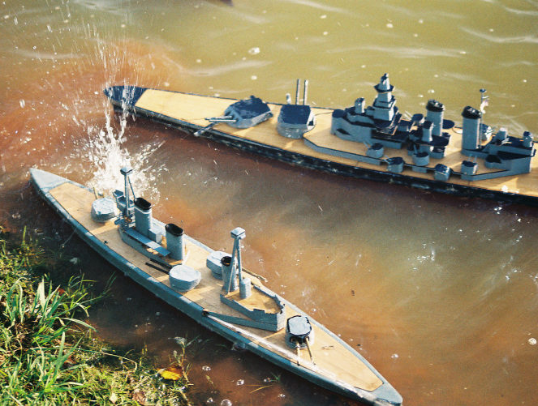
Model Warship Combat (MWC), Inc. was founded in 1998 by a group of veteran model warship combat captains in order to provide a national organization dedicated to the safety, promotion, development and fun of R/C model warship combat. MWC, Inc. is organized as a 501(c)7 non-profit corporation registered in the State of Georgia. This status means MWC is unique among the other R/C warship combat clubs and allows MWC to provide its membership with certain services not available elsewhere. MWC Inc. also sanctions combat events across the country including an annual National Championship in July and supports local affiliated groups, known as chapters, within several regions of the country.
Membership in MWC, Inc. is open to any person interested in the hobby of R/C model warship combat. There are no age limits to join, however minors must have a parent or guardian sign their membership form. The hobby of model warship combat is an excellent opportunity for parents to become involved with their children in a life-long hobby that encourages creativity through experimentation and construction of model ships combined with good sportsmanship and teamwork by participation in combat events.
MWC offers assistance to beginners in selecting and building combat ships through electronic forums and contacts with veteran captains. Local chapters of the MWC sponsor several combat events and meetings throughout the year (but usually during the winter for non-combat building sessions) that the beginner can use to aid their entry into the hobby. Our main event (basically our Super Bowl) for the year is the National Championships (Nats) held in July of each year at varying places around the country.
Since MWC is a corporation, this has allowed it to secure a liability insurance policy to cover both the organization and its members during R/C warship combat activity. This insurance is included in the price of dues so all MWC members are automatically covered.
The MWC organization can also assist local members in securing locations to enjoy the hobby of R/C model warship combat. Our safety and ship construction rules are geared towards minimizing the inherent dangers to both participants and bystanders that are posed by our ships. Safety is the number one driving force behind MWC. Having fun and good fellowship with friends is the second. 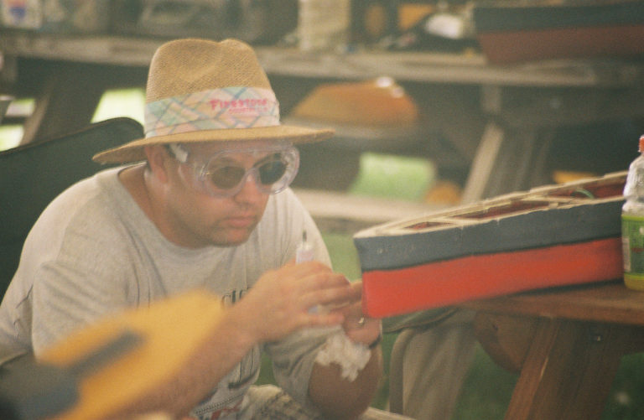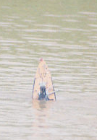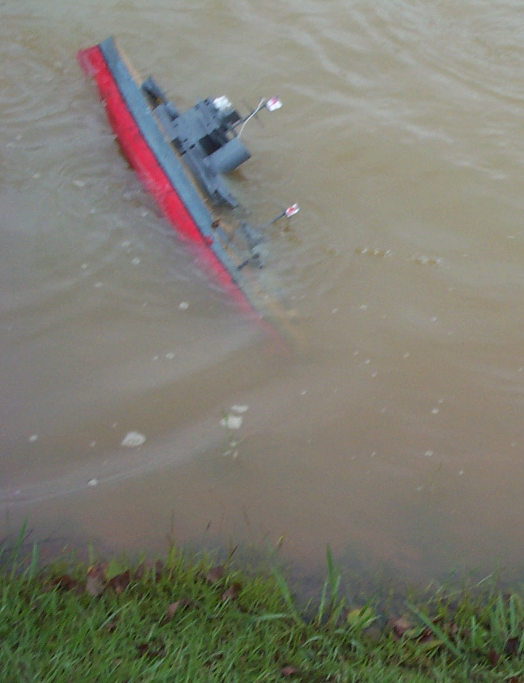

Membership Information
Have you seen enough? Do you like what you see? Do you have what it takes to become a member of this elite group of battlers?
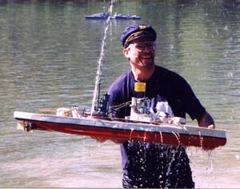
John "Curly" Barrett retrieves his ship after sinking.
He'll have it back on the water in an hour which is why he's
smiling. Even when you sink, the MWC offers a good time.
If you feel that Model Warship Combat is for you, join now by downloading the handy on-line form in one of the following formats: Microsoft Word (.doc), Adobe Acrobat (.pdf) or HTML.
Services
- A national set of rules which allows you to battle with people all over this great nation. You can battle with anyone in the MWC since we all follow the same set of rules. Something which is quite unique in the hobby.
- The MWC is the only organization to offer it members direct general liability insurance coverage for the operation of model warship combat related activities with membership. This provides protection to the organization and the membership throughout the country.
- $2,000,000 annual general liability aggregate coverage for MWC members, chapters and site owners.
- $1,000,000 per occurrence coverage for MWC members, chapters and site owners.
- Access to the members-only mail list, providing quick and informative solutions to your building and battling questions.
- Free space on the organizations webserver for your own MWC related webpage.
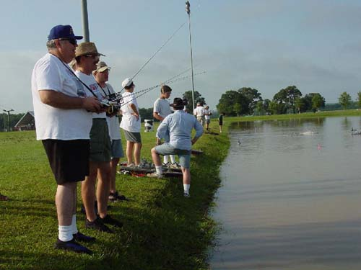
A few of the friendly battlers at an MWC event waiting on the shoreline for a battle to start.
- Memberships run from January 1st to December 31st.
- First time members joining after July save 50% on their membership fees.
Events
- Each year the MWC holds its premier event, the MWC National Championships (Nats). This even rotates around the country to allow everyone an opportunity to attend and consistently attracts the best battlers in the hobby. The MWC Nationals is the biggest event in the entire hobby attracting upwards to 60 captains for the week of battling.
- The MWC sanctions events all over the country throughout the year. Membership is required at all sanctioned events.
Products
- A year's subscription (four issues) to TF144, the MWC newsletter, filled with battle reports, tips and tactics as well as interesting trivia.
- Group buying power. Our members often purchase items in bulk from vendors at greatly reduced prices.
- A tight-knit group of wacky friends who are willing to travel hundreds of miles to let their best friends blast their most prized possession into toothpicks. It's no wonder they call this hobby the "magnificent obsession".

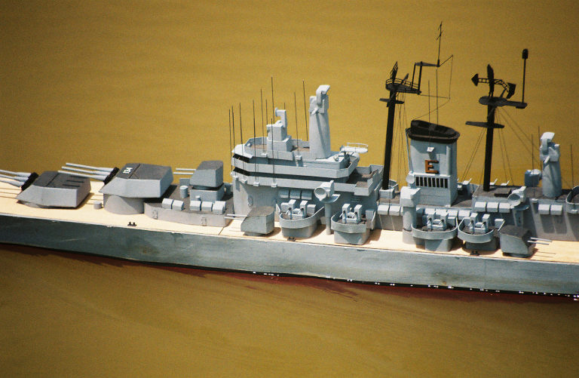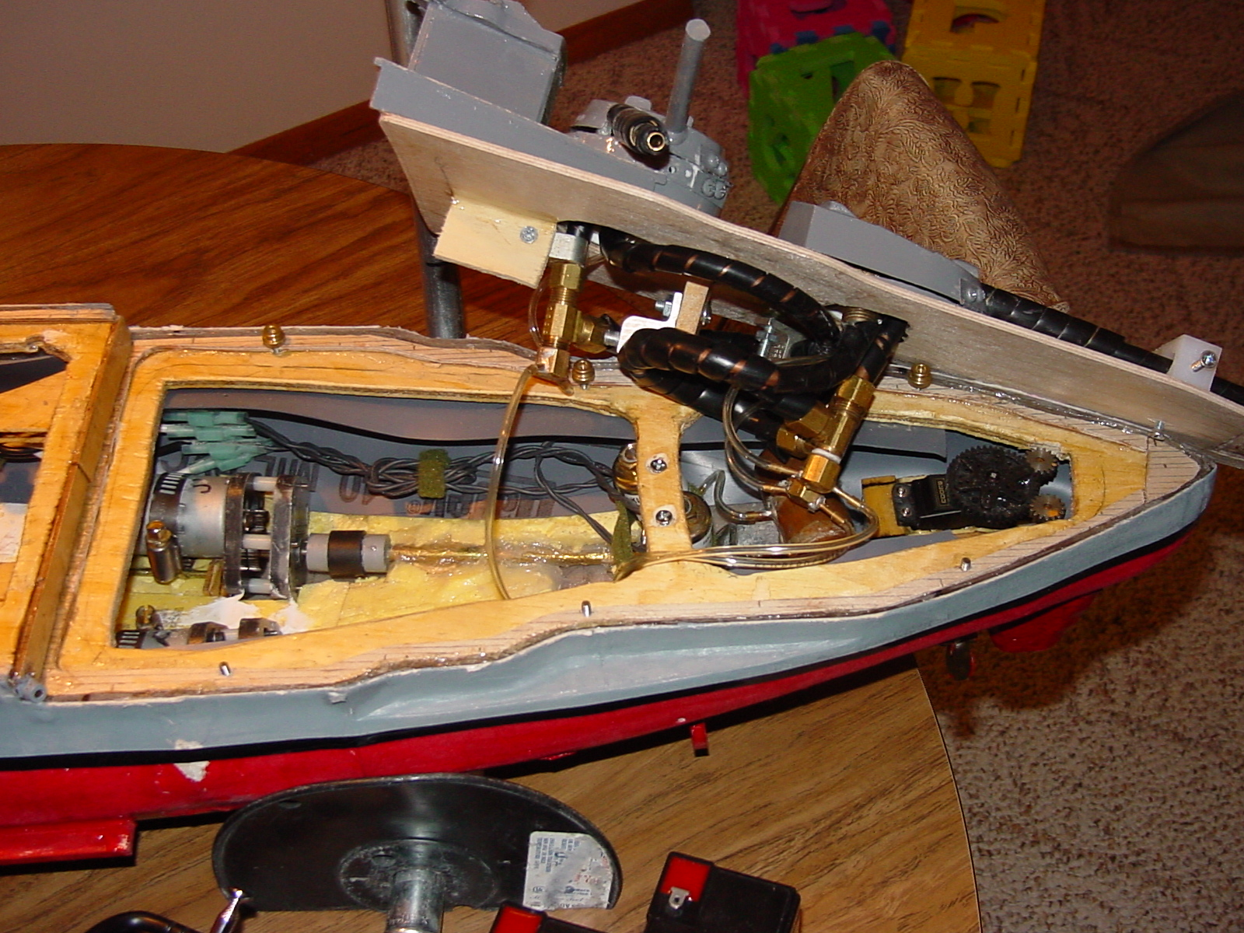
Local Contacts
Roseville
John "Curly" Barrett barrel010@tc.umn.edu
Port Polar Bear
Roseville, MN 55113
Home: 651-639-8329 (6PM-9PM)
West St. Paul
Larry Dahl lsd@planet8.tds-eagan.imco.com
Port Polar Bear
West St. Paul, MN
Home: 651-450-0275 (8PM-11PM, Weekends 10AM-11PM)
Chanhassen
Bob Hoernemann r_hoernemann@hotmail.com
Port Polar Bear
Chanhassen, MN
Home: 952-448-8808 (6:30PM-8:30PM Weekdays, Weekends 10AM-8PM)
We have other local battlers in Chaska, Jordan, Mora, St. Cloud, Iowa and Wisconsin.

Good Web Sites
mwci.org The home page for the national club all the following sites are on the links page.
strikemodels.com
Excellent collection of kits and accessories for the R/C warship hobby. The best place for a beginner to start.
Battlers Connection battlersconnection.com
"Has an excellent collection of kits and accessories using the latest manufacturing techniques. For keeping you on the
competitive edge in R/C model warship combat. The beginner's best choice." - Charley Stephens

Texas Naval Brigade - Gulf Coast Squadron (TNB-GCS) mwci.org/chapters/TNB-GCS
GOOD PICTURES ON THIS SITE
"The TEXAS NAVAL BRIGADE - GULF COAST SQUADRON is a group of new 1/144 scale model warship battlers in the Houston, Texas area. The club is building both Axis and Allied warships, and is an active chapter of Model Warship Combat, inc. The website chronicles their experiences while building cruisers." - Steve Reichenbach
The Commodore's Page mwci.org/chapters/cpearce
GOOD PICTURES AND ARTICLES ON THIS SITE
Geared towards the Allied end of the battling spectrum, this site contains many excellent photos.
Ron Thibault's Page mwci.org/chapters/rthibault
VERY GOOD ARTICLES ON THIS SITE
"A combat site with several 'How To' articles covering a broad range of ship construction, as well as pictures and links to many other sites. In addition information that will be of interest to those who use a lathe in the fabricating of ship components." - Ron Thibault
Port Polar Bear (PPB) mwci.org/chapters/PPB
THE LOCAL MN CLUB
The guys up in the great white north. Rumors abound that they fit skates to their ships for winter use.
Florida Region Attack Group (FRAG) mwci.org/chapters/FRAG
LOTS!! OF GREAT PICTURES ON THIS SITE
"Representing the Florida gang of bb-happy modelers (one of the fastest growing in the hobby) with links,
pictures, and articles, and contact info. We battle in Orlando, north Florida (Ocala area) and south Georgia (Baxley & Atlanta) approximately once a month." - Jeff Lipp

FAQ
A. General
What is a FAQ?
A "FAQ" (pronounced fack) is a text file where Frequently Asked Questions (FAQ) are stored for people interested in a subject being discussed at that location. In the case of this FAQ, it pertains to frequently asked questions within the Model Warship Combat organization. - Brian Eliassen

Do the models actually sink?
Yah, you betcha. In fact, we tend to tune our rules based on the frequency of sinks. According to our rules all combatants must be sinkable. As we tend to fight in waters shallow enough for wading, sunken ships are normally found and recovered quickly. - Larry Dahl

Why would anyone allow their model ship to be shot up and sunk?
Because you get to shoot up and hopefully sink someone else's model ship. If your technical and tactical skills are fairly good, then you won't sink that often. But you do have to put your ship on the line in order to sink someone else's! - Larry Dahl

Are the ships easy to repair and how do you do it?
The ships are designed and built to take the punishment, and are very easy to repair. Usually a repair is no more than covering a bb hole with a silkspan patch (very much like tissue paper but stronger) and a lightcovering of glue or quick-drying paint. When dry, the hole is patched. - Larry Dahl

Isn't water bad for your electronics?
The sensitive electronics, including the bulk of the radio equipment, are usually protected from the water, either through the use of watertight boxes, or by some other form of waterproofing. The electrical drive motors aren't usually protected, as it's not too hard to find inexpensive motors that aren't bothered by exposure to water. - Larry Dahl

Why don't you arm all of your main guns?
There are several reasons. For one thing, packing a bb cannon in for each main gun can be difficult for some people, especially beginners. Also, one of our rapid-fire bb cannons is more than enough to sink another ship if it can be placed on target. So, to keep beginners from being totally out-classed by old vets, the number of units (a unit being either a 'standard 50 shot bb-cannon' or a 'pump with a standard 1/8" outlet') per ship is regulated by our rules. The number of units for ships most commonly battled range from 3 units up to a mzximum of 8 units. One of our guiding principles from the early days has been to try to keep the ships and systems from getting too complicated and/or expensive for the normal guy off the street. This is another reason for cutting down on the number of units per ship. - Larry Dahl

Why do you need pumps?
Partially for safety reasons. In an effort to keep the power of the bb cannon systems down, the sides of the ships are sheeted with 1/32" balsa wood, to allow easy penetration. But since we're building and battling battleships here, we don't want a single hole to sink our beauties. Thus, a captain has the option of using pumps to simulate the punishment absorbing capabilities of the full-sized prototypes. The ship has to take enough hits to overcome the capacity of his pump(s) in order to sink. - Larry Dahl

So you can actually fight battles just like Jutland or Surgio Straight?
Well, yes and no. We can build the ships from these famous battles, but we don't normally fight in a 'line of battle'. Since it is very difficult to aim a bb cannon to hit at long range when one isn't even on the ship but standing on shore, most of our battles go right to the melee stage. In addition, due to the safety rules, many of the cannons are mounted to fire either off the bow or the stern, which means that youd' be firing on your own fleet if you were sailing in a line of battle. - Larry Dahl

Why go to all this trouble if you can't fight like the real ships?
When we all first heard of this hobby, many of us had visions of duplicating actual battles. But it just wouldn't work, as there are several differences between our model ships and the real ones that make this quite difficult, such as:
- The safety differences, limiting the gun placement, means that many ships are limited to bow and stern cannon firing, thus the classic naval manuever of crossing you opponents' T now has exactly the opposite effect in our hobby versus real life.
- Targeting differences, with cannons being aimed by people not actually on the ship and siting down the cannon barrel. This makes targeting enemy vessels much more difficult. The result is that we fight at ranges that are totally unrealistic in real life for anything other than a night battle (point blank). In 1/144th scale, the battlecruiser action at Jutland would have taken place with ships about 60 yards apart. We wouldn't hit a thing at that range with our model ships.
- Our ships aren't armored like the real ones, again for safety. Our ships must be easily penetrated. We compensate for this with pumps. Shells from a destroyer would bounce off a battlewagon in real life, not in our hobby.
- Our 'shells' are not explosive like in real life.. Therefore magazine explosions and fires are rare events.
- One of our main objective is to have fun while sinking model ships. Fun was the last thing on the mind of any man in the midst of a real naval battle. Real naval architects tried to design ships and systems that would withstand the worst an enemy could throw at them, and continue to function. Our people attempt to 'balance' systems to maintain a healthy level of sinks in combat versus total pulverization. In other words:
If no one sinks: No fun, everybody packs up and goes home. If everyone sinks or suffers mega-damage: No fun, everybody packs up and goes home.
Obviously we try to maintain the amount of damage dealt out to a 'reasonable' level. Down angled sidemounts, at the distances we fight at, are killers.
- Another of our objectives is to keep things simple and inexpensive. When people design fancy and expensive items that give them an advantage over people who don't have them, the items are usually outlawed. In our hobby, radar and radar-controlled cannons are totally outlawed. Why? because we want everybody to have fun, not an arms race.
- The water is still at 1/1 scale. Trying to have scale speeds and scale manuevering is very difficult. Thus we instead sail our model ships at speeds that are close to what is called "dynamic similarity", where both the ship and the model have equal Froude numbers. Doing this allows our models to behave hydrodynamically similar to the real ship. This is a difficult subject to explain without the benefit of a degree in fluid dynamics, and we get many comments from spectators because they think this speed is too high, but that's why we picked.
But in so picking this 'speed limit', we still have other concerns that are different from the real vessels. The actual vessels try to squeeze as much speed as they can out of the ship without compromising too many other aspects of their design requirements. As such the designers are fighting physical limitations only. Our model ships can easily reach very high speeds, and most must be 'regulated' in some means to the speeds we have selected. Most real ships did not run speed tests before a battle to ensure that they did no more and no less than some table said they should. Our model ships do have to do this.
And as was mentioned before, this set of rules that we use evolved from the period of time when it was difficult to even hit another ship, let alone sink it. In that time we came to like the game and its differences because it was still fun. And the ships usually sink like the real ships, which is a real kick everytime it happens, and usually results in cheers arising from the shoreline.
The ruleset we use started at the time when it was difficult to even get the bb cannons to fire reliably. As technology advanced, the rules changed, but always with the intent of keeping the game fun for both rookies and veterans alike, and playable at the same time. When systems get too good, and we begin seeing too many sinks, or conversely not enough, then usually we try to adjust the construction of the combat systems to bring the game back into balance. - Larry Dahl

B. Organization
What is the MWC?
Model Warship Combat, Inc. (MWC) is a non-profit corporation formed for the express purpose of building and fighting 1/144 semi-scale warships models from the World War I and World War II eras. The warships battle by firing bbs at each other. Safety, fun and good sportsmanship are the other high lofty goals to which we aspire. - Larry Dahl

How can the MWC have a long and glorious history if it started in 1999?
The story is that the first gentlemen (The Three Founders) who mounted radio-controlled bb cannons on model warships did so back in the late 1970's. Out of their efforts came the IRCWCC, or the International Radio Controlled Warship Combat Club. This is the club that developed and refined the game the MWC uses today, and the IRCWCC can rightly claim to be the oldest r/c scale warship combat organization in the world. The game they developed was for the most part, just fine. The reason for the creation of the MWC was that there had developed what can be best described as a personality schism within the IRCWCC. There was no means for controlling or correcting this problem within the club rules, and peer pressure just didn't work. After watching many good people leave due to this problem, the founders of the MWC decided that the IRCWCC couldn't survive with this schism, and so they opted to take one side of the schism and form a new organization. In so doing they recognized that part of the IRCWCC would leave that group and join them, others would remain solely in the IRCWCC, and a third group would probably join both clubs. Since they were forming a new organization, the MWC founders have tried to alter the organizational makeup and procedures such that another schism would hopefully never develope within their ranks.
Being as the personality differences were the main cause for the breakup, it was difficult to find a good reason for banning the one part of the schism from the MWC without seeming to accuse them of something nasty. Were they really nasty, or were they just proactively defending their own viewpoints? This can probably be debated many ways and most of the data was entirely subjective. The one thing we could all agree on was that there were a certain few within the one schism that were seemingly involved in the majority of arguements, whereas in the other somewhat larger side of the schism the argumenters were varied and many. On that basis the MWC founders drew their line for excluding certain IRCWCC members from the MWC. One of the stated principles for the new MWC was good sportsmanship. Does this mean that those excluded weren't good sportsmen? This undoubtably can be argued from many differing viewpoints, but to be honest, the MWC founders aren't interested in dredging up all these old arguments. What we do think is that the absence of a certain segment of the IRCWCC will remove the tension and the arguments that were causing some of us to be poorer sportsmen than we wanted to be. - Larry Dahl

C. History
Which side has won the most Nats, what was the score and where was it held?
Since the creation of the MWC:
- 1999 - Axis (148,950 - 38,200 in Oklahoma City, OK)
- 2000 - Axis (121,315 - 108,140 in Perry, GA)
- 2001 - Allies (??? in ???, MO)
- 2002 - Allies (153.535 - 138,875 in Houston, TX)
- 2003 - Allies (185,035 - 138,470 in Perry, GA)
If you have the missing 2001 scores, please let me know. - Brian Eliassen

D. Safety
With all those bbs flying around, is it safe?
Well, having remote controlled bbs flying around seems to be asking for trouble, be we try our best to think of safety. As mentioned above, the bb cannons are relatively low-powered, firing the bbs hard enough to give a good sting but not hard enough in most cases to break the skin. Thus our main concern is for eye-safety, and we have other safety rules in place to try and keep the bbs down below eye-level of most adults. For instance, the destroyers and cruisers tend to roll quite a bit when they turn, and so bb cannons are only allowed to fire directly off the bow and/or stern on these ships, to cut down on the shots going high. Even with all of our precautions, bbs will bounce, and as such, eye protection for all combatants and spectators is mandatory. - Larry Dahl

E. Construction
1. Hulls
Where do I get kits or plans?
Battlers Connection and Swampworks are both good places to buy.

What's better, fiberglass or wood hulls?
The answer to that question depends on what you want. If you want a quick, relatively easy to build ship, then a fiberglass hull is the thing for you. However, you have to keep in mind that in the long run, fiberglass hulls can be less durable than wood hulls, and due to the lack of interest of some people who make the more obscure fiberglass hulls, some of them tend to be lacking in scale fidelity, or relatively poorly made.
On the other hand, while a wooden hull is more difficult to build, and must be sealed carefully to prevent water damage, a well built wooden hull is much more durable than a fiberglass hull, and will last much longer. Another consideration for the veteran battlers (who are the ones who typically build wooden hulls) is that they don't have to deal with someone else's mistakes in research or execution, but can rather research the best plans they can find and build ships which are as much works of scale art as they are warships.
So, in the end, the answer to that question simply depends on what you want. If you want a quick fix, then fiberglass is the answer for you. If you want a little something more, then perhaps you should consider plywood. - Chris Pearce

There are pros and cons to both. Both types of hulls are widely used in the hobby. Ultimately it comes down to your personal choice, situation and capabilities.
Fiberglass Hulls
----------------
Pros: You don't have to build the hull (great for the novice.)
Lighter than wooden hulls.
Slightly more room inside for equipment than wooden hulls.
You can get on the water faster.
You don't have to spend money on accurate hull plans.
Minimal ship-building skills required.

Cons: Limited choice of hulls (choice widens every year though.)
You cannot make changes to the hull design easily.
Difficult to fix mistakes (e.g. Oops! Didn't want to cut THAT out)
Someone else made it. :(

Wood Hulls
----------
Pros: Wide choice of ships.
You have complete control over the design & building process.
Extremely durable provided it is built right.
You can make it as scale as you want.
Easier to repair/fix mistakes.
The wooden structure looks so cool.
Builds modelling skills.
YOU built it!

Cons: You need good plans ($$) to make a good hull.
Takes more time and effort to get it battling on the water.
Slightly heavier than fiberglass hulls.
Slightly less space inside for equipment compared to fiberglass.
Needs basic ship-building skills.
- Alekh Bhurke

Where do I get fiberglass hulls?
Fiberglass hulls are available for sale by individuals and companies. Two suppliers have been very helpful to rookies who want to purchase a fiberglass hull kit; Swampworks Manufacturing and Battler's Connection.
Swampworks has the greatest selection of hulls, and complete warship kits and accessories. The owner of Swampworks, Steve Milholland, has been in the hobby for many years, and is very helpful to rookies building their first warship. The kits are very complete, including everything you need to construct a working model warship.
Battler's Connection is a newer company, owned by Charley Stephens. Charley is able to produce a new hull if only 3 people are willing to order it. He does not have as many off-the-shelf hulls or "kits" (hull, turrets, and plans) as Swampworks, but Charley does also sell most of the accessories you would need to build a warship. His hulls are of similar quality, and can be ordered with thin or thick fiberglass.
If you are more experienced, you probably already are aware of the other folks who also produce fiberglass hulls. For the rookie, however, I suggest going with Swampworks Manufacturing or Battler's Connection. - Steve Reichenbach

2. Cannons
Where do I get BB cannons?
Battlers Connection and Swampworks are both good places to buy.

Can I make them myself?
Yes you can. But the first guns you make yourself never work quite as good as the ones you can buy. Once you become a “Veteran” battler you will want to try to build your own. Kind of like a Jedi and a lightsaber.

Are poppet valves or solenoids better?
Depending on the ship in question, one type of valve may be better than the other. A solenoid type valve seams to have slightly higher fire rates, and may give slightly more power. However, the price is increased weight, and a relatively complicated electrical system. Solenoid valves are best used on on large ships that have extra weight to use, and need multiple firing cannons. Such as most class 5 ships and larger. On more weight challenged ships, the weight saved from lighter valves can be used for more necessary things like batteries, and CO2 systems. Most class 4 and smaller ships should be using poppets. - Chris Au

How do I mount the cannons to the ship?
There are as many ways to mount cannons to the ship as there are captains. In general, if you are using a single cannon, it should be mounted so that it hits the water relative to the ship the same place every time. So the mount should be rigid and not allow the cannon to bounce around. Things that have been used for this sort of mount, that work fairly well are: zippy ties, wire ties, tabs soldered to cannon and screwed to decks, breach cradles, various clamps made from wood, plastic or metal. Multiple firing cannons (double, triple, quad) need to be fixed so that they hit near each other for best aim and effect. So some sort of clamp is needed to hold all the cannon in position. The idea is to make sure that they will not move relative to each other first, then with respect to the ship. - Chris Au

How do I do a double/tripe/quad stern gun setup?
It is necessary that each cannon have it's own valve. For double cannons it is possible (but a nuisance) to use poppet valves. Otherwise each cannon will need a solenoid valve, that can be setup to test fire or tweaked separately. The solenoid valves should generally be mounted close to the cannon so that hose runs can be minimized. Also a volume tank should be used so that each cannon has enough gas to fire. The solenoid valves should be mounted low in the hull for best weight distribution, yet no so low that they are in the water. - Chris Au

What's an accumulator tank?
An accumulator tank holds gas, under cannon firing pressure, next to the cannon valve. An accumulator tank improves cannon performance by providing larger gas flow to the cannon. Accumulator tanks are especially important when using multiple cannon setups. Accumulator tanks can weight a substantial amount when compared to the weight of the ship, and this should be taken into account. They are typically made from copper and/or brass tubing and sweat fitting that are sufficient to withstand the cannon pressure. - Chris Au

What's better, a Geek, BC or Foster breech?
All work good for battling. The Geek Guns do not hit as hard but the never jam and are very low maintenance.

What are some of the common cannon failures?
For manufactured cannons (Swampy type): Crud in cannon from sinking, bad bb in breach/magazine/barrel, broken barrel, corrosion in cannon from sinking and letting water sit. From home made cannons, all the above plus: bad solder joints that leak/have solder blocking/fall apart, flux inside, bad machining on brass parts, springs/pistons that jam (most common). Also for all types, bb dents in barrels, magazine, and lift tube. - Chris Au

3. Batteries, Motors & Pumps
What's the best kind of battery to use?
SLA (Sealed Lead Acid)

How many Amp Hours (Ah) do I need?
The general rule of thumb is to use a battery that will supply all your electrical needs over an entire battle. I first bought a 7AH battery for my Class 3 cruiser based on what other captains were running in their similar ships. When I finally got all the gear into the ship, I was a couple of pounds overweight. I reviewed the situation with others and was reminded that the rules allow Class 3 ships to change batteries between sorties. I also did a load test to find my total current draw. The test showed between 3.5 and 3.75 amp draw with drive and pump motors running. I then located a 3AH battery that weighed less than half the 7AH battery (1.6 lbs compared to 3.75 lbs). In my sea-trials, I get about 45 minutes of run time without a noticible drop in speed of the ship. Since most sorties last about 1/2 hour, I should make it through a sortie. - James Hovis

What's better, 6 or 12 volt systems?
6 volt, most motors are made for 6 volts

What are some common motors in use today?
Since speed is limited a standard surplus motor is good for the drive system. The best pump motors are “Stinger” motors

What are some common props in use today?
Dumas 3112 & 3113 a three blade 2” prop or the Dumas 4 blade 1½”. These are better because they are cast and do not break very easy. You can also get soldered together props from Swampy and B.C. They are cheaper but blades do break off when you hit something hard. The extra money spent here is worth it.

4. Radio
What's the best brand?
Futaba or Airtronics. Get a 6 channel, you’ll need it when you move up to a big Battleship (You will).

How many channels will I need?
Six

Should I run my receiver off my main battery?
There are some advantages and disadvantages to running a radio reciever using a 6 volt ship battery. The primary advantages include no need to recharge a separate receiver battery, faster servo response, and saving the weight of the additional battery. The main disadvantages include the possibility of permanently damaging the receiver, interference, and losing control with weak batteries.
An important consideration using this technique is to install electrical plug connectors that will prevent the receiver from being damaged by incorrect connection to the battery. The receiver must not be incorrectly connected, or it will be permanently damaged.
This technique is very helpful in small ships where weight savings is important, and is a useful option for those who like to simplify systems by eliminating the radio battery from the equation. - Steve Reichenbach

How do I protect my radio from water damage?
In a water tight radio box.

What's all this about Air versus Surface frequencies?
We have to use the ground channels and can not use air channels

5. Superstructure
How much do I need?
Not much and it does not need to be pretty, according to the rules. Anything over 1” sq inch (144th scale) needs to be modeled. Lots of people do put a lot of work into the superstructure to make it look good and there is a best of scale award at NATS

What's the best way to do it so that it doesn't get shot up?
If you have a large boat (class 5 and up), you can use 2 mil sheet styrene for the vertical surfaces. After testing at a range of 10", the plastic has only a small dent. This material will let you put on more detail that would otherwise require many hours patching. The cost of a 4'X8' is around $15.00 u.s. (this will build many ships). If you need ordering information please e-mail me. - Louis Meszaros

6. Hull Sheeting
What's the best way to apply the silkspan and balsa to the hull?
Contact cement or CA glue.

What are some common sheeting failures?
Not enough glue to hold the sheet to the hull.

7. Internal Armor
Why do I need it?
Internal armor is that plastic stuff, just inside the hull of your ship, that prevents bb's from coming out the other side, and (hopefully) from damaging any sensitive components inside your hull, like cannon magazines, or electrical connections. You need it because our cannons fire powerfully enough that they will go through both sides of a hull, and exit holes are typically catastrophic. That, and if they should strike an unprotected cannon magazine, they can dent it can cause the cannon to stop firing, or can break electrical connections and cause a ship to go dead in the water, or any number of other, very bad things. - Chris Pearce

What's best to use?
The best, and most easily available armor material I've found is available at your local grocery store, in the form of 2-liter soda bottles. Buy several, enjoy the contents, and then cut the bottles into strips. Then, screw the strips onto your ribs, or some other kind of mount inside your hull. Make sure that there are no large open gaps, or cracks where bb's can get through, and that the armor extends from below the impenetrable area at the bottom, to high enough that a bb cannot pass through on the top, either. Likewise, at the bow and stern, there should be no room for bb's to pass through. At the same time, there needs to be open area beneath the armor at the bottom, so that it doesn't trap water and cause your ship to list and sink. - Chris Pearce

You can also use shower pan liner. Get it at Home Depot in the shower isle.

What are some common armor failures?
Common armor failures include:
- Inferior plastic mesh, plexiglass, or other armor cracking and breaking up into pieces after repeated impacts, allowing rounds to pass through the wreckage.
- Inadequately secured armor coming loose and flopping around inside the ship, allowing rounds to pass by it.
- Armor that's not adequately fastened at the bow or stern being blown out through the other side by triple stern gun fire.
- Large gaps in the armor, or between armor pieces allowing rounds through between them.
- Armor which is so rigid that it causes the bb's to bounce back out through the hull skin, leaving a nasty exit hole.
- Chris Pearce

8. Electrical Wiring
What guage of wire is best to use?
12 or 14 for the main wires and the pump. 16 or 18 for the guns and lights.

Should I use fuses?
NO, KISS principle.

How should I prevent water damage to connections?
solder everything

What are some common wiring failures?
Bad soldering

Aft | Towards the rear of the ship. Used in the sense of direction such as, "I went aft on the ship."
Battle Units | See units.
Bow | The front of the ship.
Bow Cannon | A cannon which fires into the 30º bow arc. Generally, these cannons appear only on class 3 and lower ships due to safety reasons. These cannons are good for distance sniping and shooting targets in campaign battle. Sometimes referred to as a "bow gun".
Bow Quadrant | The 30º area of the bow 15º to each side of the longitudinal centerline of the ship. This is the location where bow cannons are aimed.
Bow Side-Mount | A side-mounted cannon that is in the bow of a ship. Good cannon for pursuit to finish off a wounded enemy.
Breech | The area of a cannon which restricts the movement of the BB until such time as enough pressure builds up behind it to fire.
Casemate | An armored area on the side of a ship which usually holds smaller guns. An area often ruled as impenetrable in our hobby.
Casement | A common mistake when trying to refer to casemate.
CO₂ Bottle | The reservoir which hold the liquid CO₂ within the ship.
Country Designations | DKM - Germany : Deutsch KreigsMarine (e.g.; DKM Lutzow)  FNS - French : French Naval Ship (e.g.; FNS Richelieu)  HMAS - Australia : H(er/is) Majesty's Austalian Ship (e.g.; HMAS Australia)  HMCS - Canada : H(er/is) Majesty's Canadian Ship (e.g.; HMCS Halifax)  HMS - British : H(er/is) Majesty's Ship (e.g.; HMS Invincible)  IJN - Japanese : Imperial Japanese Navy (e.g.; IJN Nagato)  RMI - Italy : Regia Marina Italiana (e.g.; RMI Andrea Doria)  SMS - German : Sein Majistate Schiff (e.g.; SMS Moltke)  SNS - Spanish : Spanish Naval Ship (e.g.; SNS Espana)  USS - United States : United States Ship (e.g.; USS South Dakota)
Deck | The surface that sits on top of the hull and supports turrets, superstructure and any detail a captain may wish to add. In the past, many navies used wooden teak decks due to its durability. In our hobby, the deck is often made from aircraft ply.
Dope | A paint used to attach silkspan to the balsa sheeting which renders it waterproof.
Geek Breech | A silicone tube design which restricts the BB's travel until enough pressure builds up to fire it. Virtually maintenence free. Also referred to as a "restrictor breech".
Gel Cell | Maintenance free battery which has the dielectric in a gel form. Larger and heavier than other battery types but they contain massive capacity which explains the popularity for this type of battery in the larger ships. Cannot be fast charged.
Fast Charge | The act of quickly bringing a battery to capacity with a specific charger. Normally reserved for NiCad batteries but some NiMH batteries can now be fast charged as well. Also referred to as "quick charge".
Five Out of Control | You're almost guaranteed to hear this at least once during each sortie. When a captain has lost control of his ship, be it steering, propulsion or an accidental beaching...he's allowed to call "Five Out of Control" and to start his 5-minute timer. Unlike calling "On Five", the captain of a ship that's on "Five Out of Control" can still shoot his cannons if they still work. After his five minutes are up, he's allowed to remove his ship from the water. Captains on "Five Out of Control" are generally very popular with the enemy.
Focsle (foc-sil) | The phonetic spelling of forecastle.
Fore | Towards the front of the ship. Used in the sense of direction such as, "I went fore on the ship."
Forecastle | Area of the deck near the bow. Originally an actual castle structure built on warships. Also called focsle (foc-sil).
Freeboard | The amount of space from the waterline to the deck. Genearally, the lower a ships freeboard, the harder it is to hit. But conversely, the lower a ships freeboard, the less reserve bouyancy available to survive a mishap.
Gunwale (gun-nil) | The point where the deck meets the hull.
Hose Barb | Fitting to hold and retain small diameter hose which is used to plumb the pneumatic system within a ship.
Hull | The portion of the ship which displaces water so it will float. This is the basic item each ships starts out with be it a fiberglass hull from a commercial distributor or a wooden scratch built hull.
Internal Armor | Thin plastic sheeting placed at least 1/4" behind the balsa sheeting inside the ship. This prevents a BB from entering one side of the ship and exiting the other. Also provides protection for internal components.
Interrupter | An internal piston within a cannon which prevents more than one BB from firing at a time.
Keel | The longitudinal centerline of the ship. Generally the lowest portion of the hull under the water.
Man in the Water | Due to the MWC safety rules, whenever an individual enters the water, for any reason, "Man in the Water" is called. Everyone engaged in battle immediately ceases all firing and moving until the "Resume Battle" is declared by the Contest Director.
Mast | Structures to hold a platform high above the water in order to facilitate viewing of enemy ships on the horizon.
Motor | Device which converts electrical energy into mechanical energy. Commonly used for propulsion and in pumps.
NiCad | Rechargeable battery based on Nickle and Cadmium. A high capacity to weight ratio which explains their popular use in small ships. Often capable of being "fast charged".
O-ring Breech | An o-ring is compressed to restricte the travel of a BB through it. Requires more maintenance as the cannons often need to be "tweaked" before battle but seems to provide a more powerful punch. The most common breech.
On Five | Is called when a captain wishes to leave the water but before he can do so, his ship has to remain on the water for a period of five minutes. When his timer has expired, he can remove his ship from the water. During this five minutes, he is forbidden from firing his cannons. This makes people who call their five early in a battle a choice target.
Poppet Valve | Pneumatic switch which allows the flow of CO₂ to flow to a cannon when a mechanical manipulation of the valve occurs via servo.
Port | The left side of the ship while looking at the ship stern-on. Opposite of "starboard".
Port Quadrant | The 150º area to the port side of the ship centered perpendicular to the longitudinal centerline of the ship. This is the location where port side-mount cannons are aimed.
Pump | Device used to remove water from the inside of a ship.
Pump Outlet | An opening 1/8" wide which allows the water to exit the ship from the pump.
Quick Charge | The act of quickly bringing a battery to capacity with a specific charger. Normally reserved for NiCad batteries but some NiMH batteries can now be quick charged as well. Also referred to as "fast charge".
Radio | Electronic components which allow one to control the workings of a ship. Often contains a transmitter, receiver and servos.
Ram | Called whenever a captain believes he was damaged due to ship to ship contact. The ship is returned to shore and the captain is allowed to examine his ship for damage.
Ram Bow | A bow which was designed to cause below the waterline damage to another ship when it was rammed. These bows all have extented bows below the waterline. Good examples are the HMS Invincible and the SMS Nassau.
Regulator | Device which attaches to the CO₂ bottle to bring the ambient pressure from 800 psi to a more reasonable and safe 150 psi.
Restrictor Breech | A silicone tube design which restricts the BB's travel until enough pressure builds up to fire it. Virtually maintenence free. Also referred to as a "geek breech".
Rudder | Vertical plane beneath the water to redirect the flow of water from the props which turns the ship.
Servo | Device which turns radio controlled electrnic commands into mechanical movement. Used to control most aspects of a ship such as steering, throttles, cannon firing, etc.
Sheeting | The 1/32" balsa which covers the windows on the hull. This allows a fired BB to easily penetrate and cause a hole.
Side-Mount Cannon | A side-mount is a cannon which fires into the 150º degree starboard or port arc. These cannons are generally angled down to deliver below the waterline damage. Due to the MWC safety rules, side-mounts are only allowed on class 4 and higher ships.
Silkspan | Thin tissue like material used to coat the inside and outside of the balsa sheeting to improve its strengh and waterproof capabilities. Often used with "dope" during the waterproofing phase of sheeting a ship. Grade 00 is widely accepted as the perfect choice for penetrability and durability.
Skeg | An area of the hull extending from a feature such as the keel towards either the props or rudder of a ship to provide hydrodynamic flaring and thus lowering drag.
Starboard | The right side of the ship while looking at the ship stern-on. Opposite of "port".
Starboard Quadrant | The 150º area to the starboard side of the ship centered perpendicular to the longitudinal centerline of the ship. This is the location where starboard side-mount cannons are aimed.
Stern | The rear of the ship.
Stern Cannon | A cannon which fires into the 30º stern arc. Most ships arm at least one and they are very popular as they can generally be mounted lower than a bow cannon. Also, when you're shooting at an enemy with your "sterns", you present a very small target in return. Sometimes referred to as a "stern gun".
Stern Quadrant | The 30º area of the stern 15º to each side of the longitudinal centerline of the ship. This is the location where stern cannons are aimed.
Stern Side-Mount | A side-mounted cannon that is in the stern of a ship. The most dangerous cannon as, if used properly, it can sink an opponent very quickly. This cannon generally discourages captains from chasing a ship which mounts one.
Stringer | A narrow horizontal support between ribs on the hull to facilitate attachment of the sheeting. Usually based on hull shape such as bulges and armor belts.
30 Second Moss | While sailing along you accidently run over a patch of moss. As luck would have it, your props become fouled with the stuff and your movement rate drops dramatically. Basically, you're a dead duck. What do you do? Since the rules state that you can't touch your ship until a period of time as expired, the "30 Second Moss" rule can be used. After calling "30 Second Moss" and starting your timer, you have to wait 30 seconds before you can bring your ship in to clear your props or wade out to get your ship if it is stuck in the moss.
Triple Sterns | Let's face it...hearing these badboys going off is impressive. Generally they do a LOT of damage above or on the waterline of a ship. They are very effective if the enemy starts taking on water as all the above the waterline damage will soon be below the waterline which all but guarantees a sink. Triple sterns generally appear on the larger ships within the hobby.
Tweaking Cannons | Just about every captain (with o-ring breach cannons) tweaks their cannons before each battle. This is to make sure the cannon is firing at it's maximum strength without seizing up. Some captains are better at tweaking than others as it's more of an artform.
Units | A measure of how many cannons or pumps a ship can have. Based on a ships size and capability, the number of units ranges from 1/2" unit for the smaller ships to 8 units for the largest. A unit can either be a working cannon with a 50 round magazine or a pump with a 1/8" outlet.
Waterline | The line at which the water rest against the hull while a ship is at rest at a specific weight.
Waterproofing | The act of rendering something impervious to water damage. Often involves coating an object in a special plastic-rubber compound.

