How to build a (awesome) pump
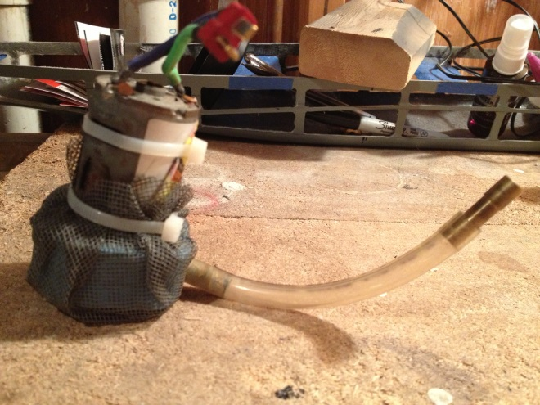
(picture 1 - before)
Impeller balance
The impeller is inherently lop sided, due to both the placement of the set screw and imperfections in the molding process. At high RPM’s this causes some vibration and pumping inefficiency. To balance it use the set screw to attach it to a short section of 1/8 inch brass rod (remember to cut a slot for the set screw in the rod about the same depth as the motor shaft is cut out). Then balance the rod on the sharp edge of two razor blades. The heavy side will roll downwards. Take a small drill bit (3/32 or less) and start drilling out the heavy side (usually the set screw side) with shallow 1/8 inch or so divots (picture 2 and 3). Repeat this process until the impeller will not reliably fall to the same side. This takes a fair amount of time and patients. Get it as close as you can, exact perfection is probably not needed.
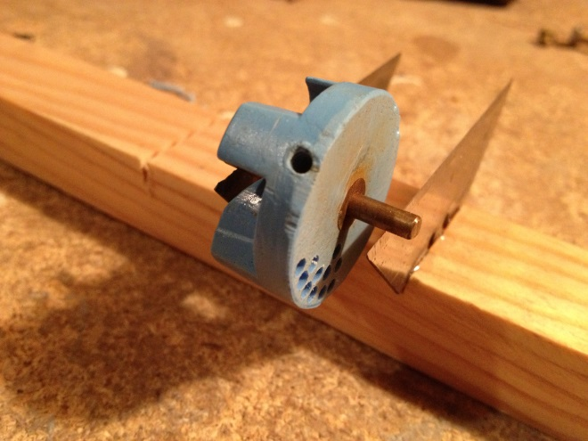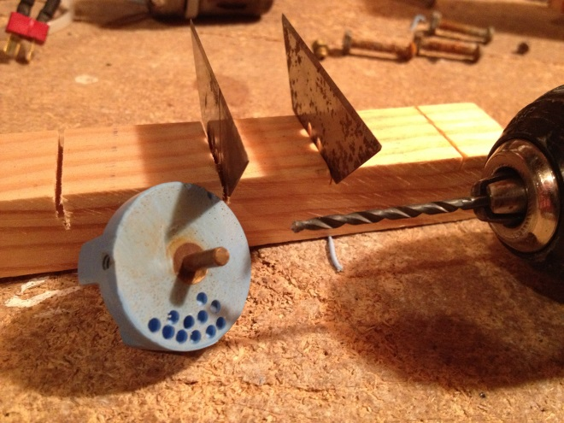
(picture 2) (picture 3)
Prime outlet relocation
I’ve noticed that as you go to higher torque/power/RPM pumps that you typically have more trouble with pump priming issues. The way that it was explained to me that made the most sense is this: Air bubbles in the pump chamber cause vapor lock. Air is less dense than water and thus wants to flow naturally upwards. Most pump designs however have the primer outlet on the middle of the side of the pump. I’ve had much fewer prime issues since I started moving the prime outlet to the top of the pump casing. Take the smallest drill bit (1/16 inch) add drill a hole from the top corner of the internal pump housing through the top (picture 4). Generally you have to put at least a 45 degree angle on it so the outlet side avoids where the pump motor bolts on. Simply take the brass screw and solder the hole shut (picture 5), you still need an access port for the set screw so you can’t close of the side hole permanently.
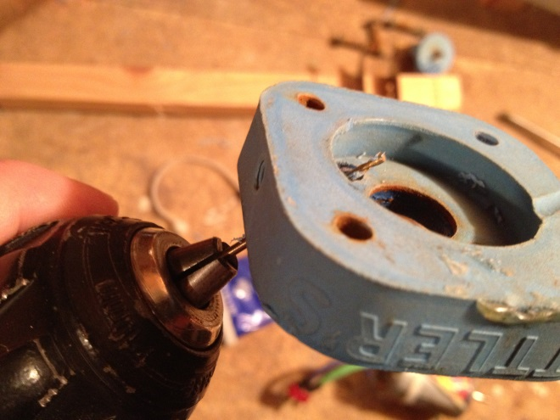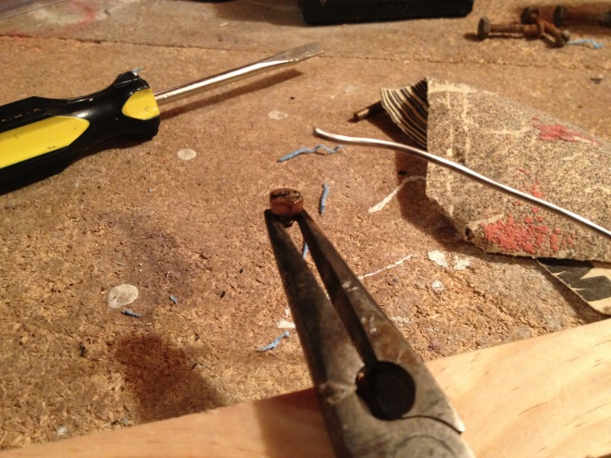
(picture 4 – of note: this is backwards from the way I drill it (go from inside to out) but the picture was better set up for demonstration purposes from this angle)
(picture 5)

Silicone the motor on
Apart from a small primer hole, efficiency mandates that you want as much of the water that is inside the pump to exit via the outlet and leave the boat. That is why I use silicone to seal both the motor to the top of the pump housing (picture 6, 7) and the two halves of the pump housing together(picture 9). Take care not to get any of the silicone into the impeller chamber which might lock it up and fry the motor (picture 8). When the whole thing is ready to go, I always take a vice grip to the top of the motor shaft and give it a few spins to make sure it is able to spin free before I hook a motor up.
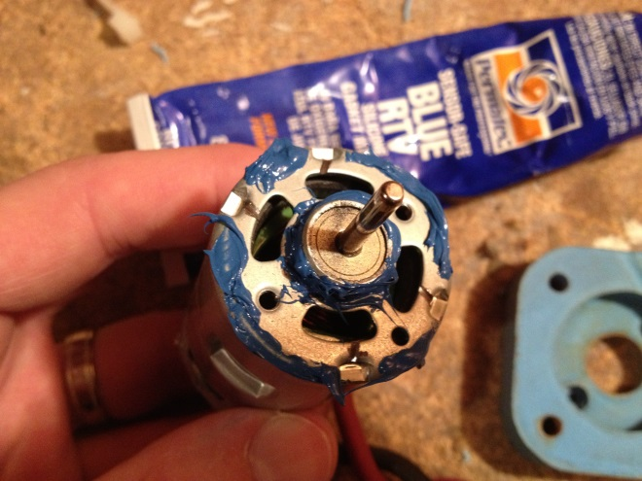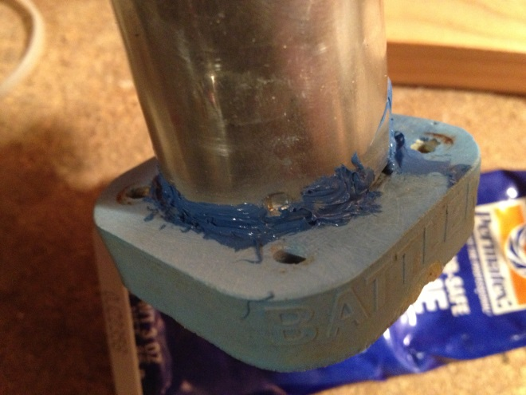
(picture 6) (picture 7)

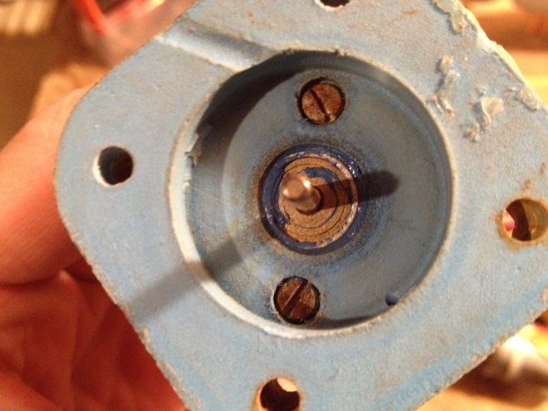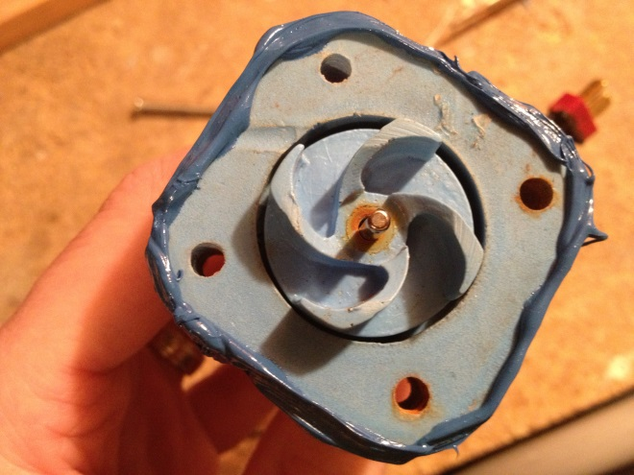
(picture 8) (picture 9)

Screw the housing together
I like to replace the standard bolts that come with the pump with longer stainless steel ones. I then put two nuts stacked together on the bottom of each bolt. This helps keep enough room along the bottom of the pump for free flow of water into the pump intake. I generally get 1.25 or 1.5 inch #8-32 bolts and cut off the excess after it is assembled (picture 10).
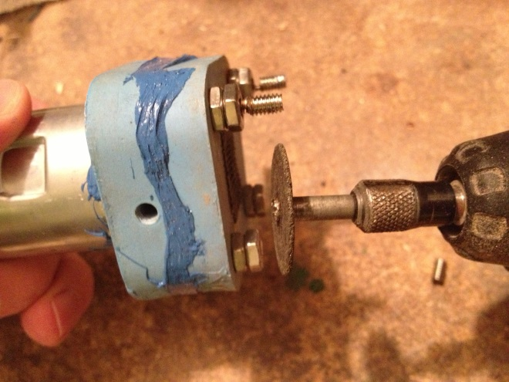
(picture 10)
Pump screen
I generally take a small square of screen and glue it over the inlet as the last line of debris blocker. I then cut out a small square of aquarium filter to go next. Finally, I use another larger section of screen to serve as the outer barrier and tape it to the pump housing with electrical tape. (picture 11)
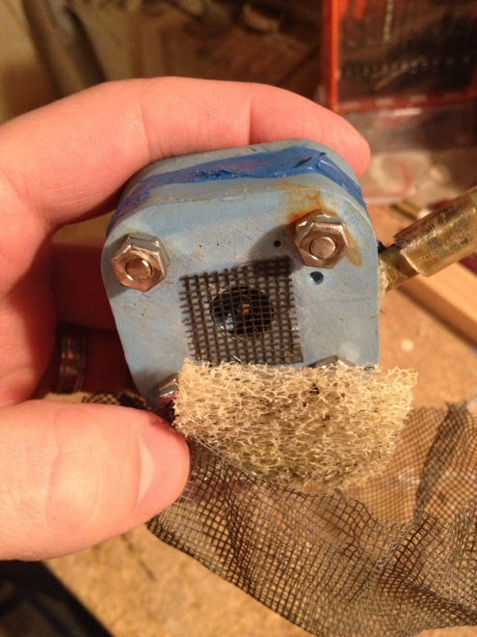
(picture 11)
Pump outlet
This is a fairly new technology to our hobby (in application but evidently not in theory). To my knowledge it was first used at Nats 2013. It turns out that if you change the flow after it passes the 1/8 inch restrictor from turbulent flow back to laminar flow, there is increased efficiency and increased pump outlet capacity. In my own testing I’ve been able to confirm the original implementer’s claim of a at least a 15% boost in output capacity. For me, this meant going from 3 gal/min to 3.5 gal/min. Another added bonus is that it takes a way a majority of the torque roll that the pump outlet causes, and even at full stream you will not dip the pump side of the ship noticeably. Furthermore, the pump outlet is much smaller so the shoreline dance to protect your radio as ships swing by is eliminated. Perhaps the best part is how easy it is to do.
The first few folks that did this simply attached an approximately 2.5-3 inch section of large diameter brass sleeve over their existing pump outlet and installed it (picture 12). I find this slightly cumbersome as the added height of the outlet makes it a bit difficult to fit into shorter ships. I was able to get the same results by simply cutting my outlet hose 2.5-3 inches from the outlet (picture 13, 14) then moving the pump restrictor to the middle of the hose and attaching a small section of wide brass sleeve (though I suppose you wouldn’t have to) to the end – I did this more to support the pump hose as it exits the ship (picture 15, 16, 17). The right length between the restrictor and the end of the line is about 2.5-3 inches, but feel free to play with it to figure out if a different length works better. Observationally, it seems that you just need to get the strong outlet jet of water to run into the side of the hose and it will work perfectly, so the natural bend in the pump hose works great. Just keep in mind that the outlet has to be measurable from the outside of the ship per the CBS rules. So far, the only down side that I have noticed is that it makes it slightly more difficult to tell when your ship is pumping hard, because even at full stream the jet of water is about 2 feet high.
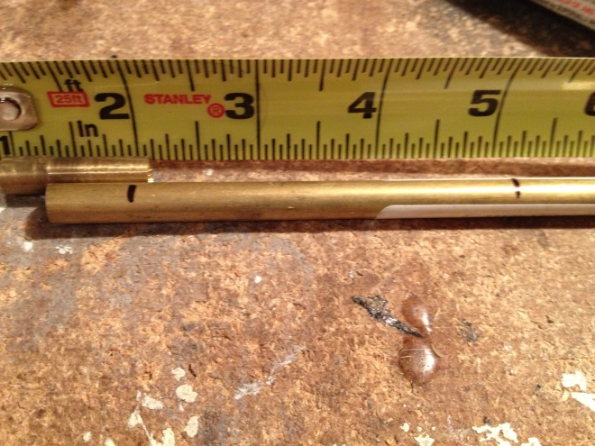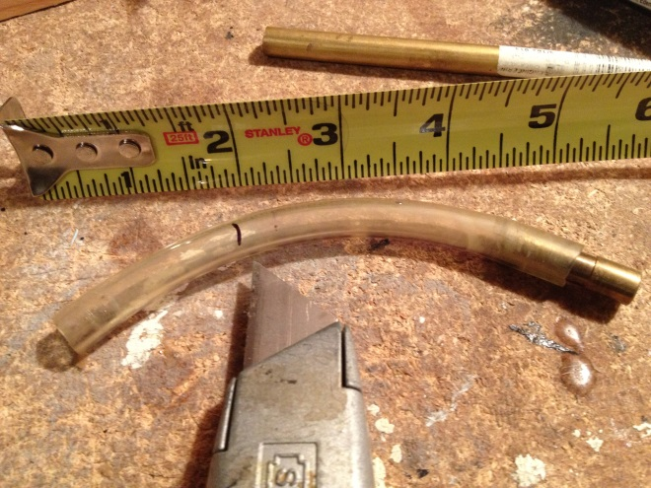
(picture 12) (picture 13)
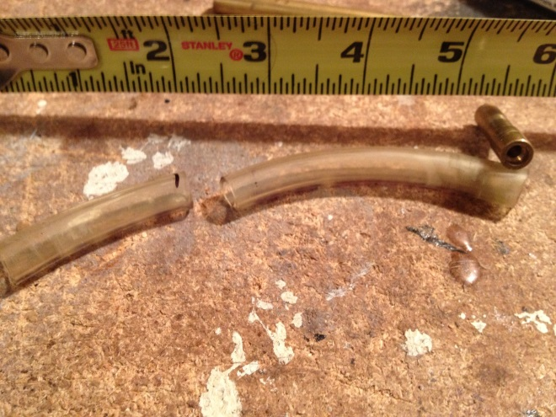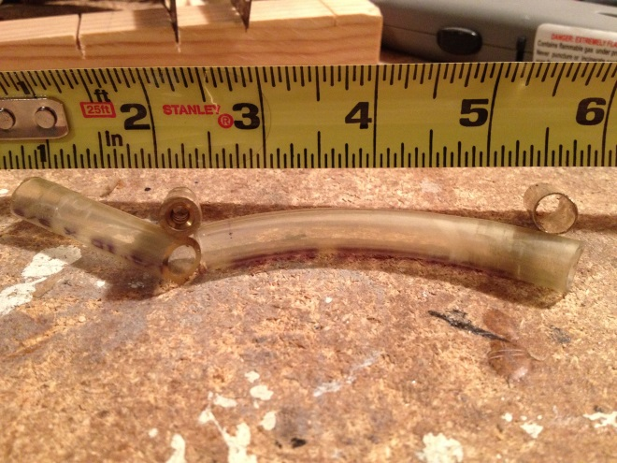
(picture 14) (picture 15)
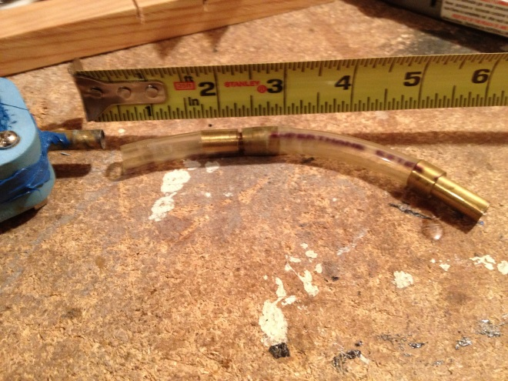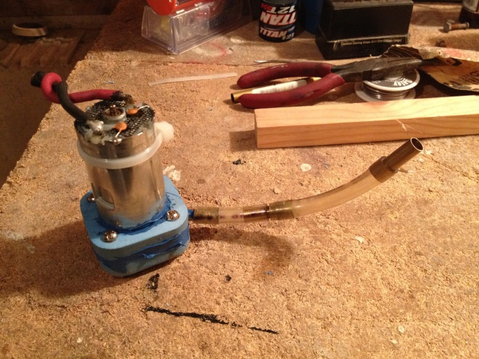
(picture 16) (picture 17)

